Q1. Write a java program to print hello world

Code:

package com.company;  
  
class hello {  
 public static void main(String[] args) {  
 System.*out*.println("Hello, World!");  
 }  
}

Output:

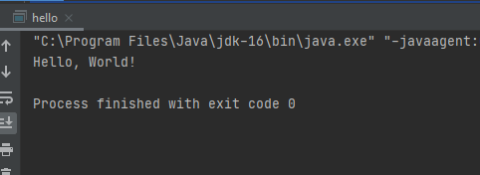

Q2. Write a java program to print 5 integers using for loop

Code:

package com.company;  
  
public class Integer  
{  
 public static void main(String[] args)  
 {  
 System.*out*.println("Output is : ");  
  
 for(int i = 1; i <= 5; i++)  
 {  
 System.*out*.println(i);  
 }  
 }  
}

Output:

